ROCA
Recurring Event Management
Mobile Screens — Batch 2
Document Type: Mobile UI Specification Batch: 2 Platform: iOS (iPhone)

1. Document Overview & Scope
This specification describes the Batch 2 mobile screens for the ROCA Recurring Event Management feature. It covers three distinct iPhone screens: the Series Overview (with stats chips, instance list, and volunteer rotation strip), the Instance Detail with Exception Badge (amber deviation banner, change diff summary, and contextual action buttons), and the Edit Scope Selector bottom sheet (three scope radio options, animated timeline preview, and Continue action). Together these screens form the core flow for viewing, understanding, and modifying recurring events on the ROCA iOS app.

Property | Value
Document Title | ROCA Recurring Event Management — Batch 2 Mobile Screens
Screens Covered | Screen 1: Series Overview | Screen 2: Instance Detail w/ Exception Badge | Screen 3: Edit Scope Selector
Platform | iOS — iPhone 15 Pro (390 × 844 pt)
Design System | ROCA Mobile DS v2 | Primary #1B5E20 | Amber Warning #FFA000
API Layer | REST v2 — /api/v2/events/series | /api/v2/events/instances | /api/v2/events/exceptions
Status | Specification — Ready for Developer Handoff

1.1 Screen Mockups
The image below shows all three Batch 2 screens side-by-side as rendered on an iPhone 15 Pro device frame. Each screen is annotated in the sections that follow.
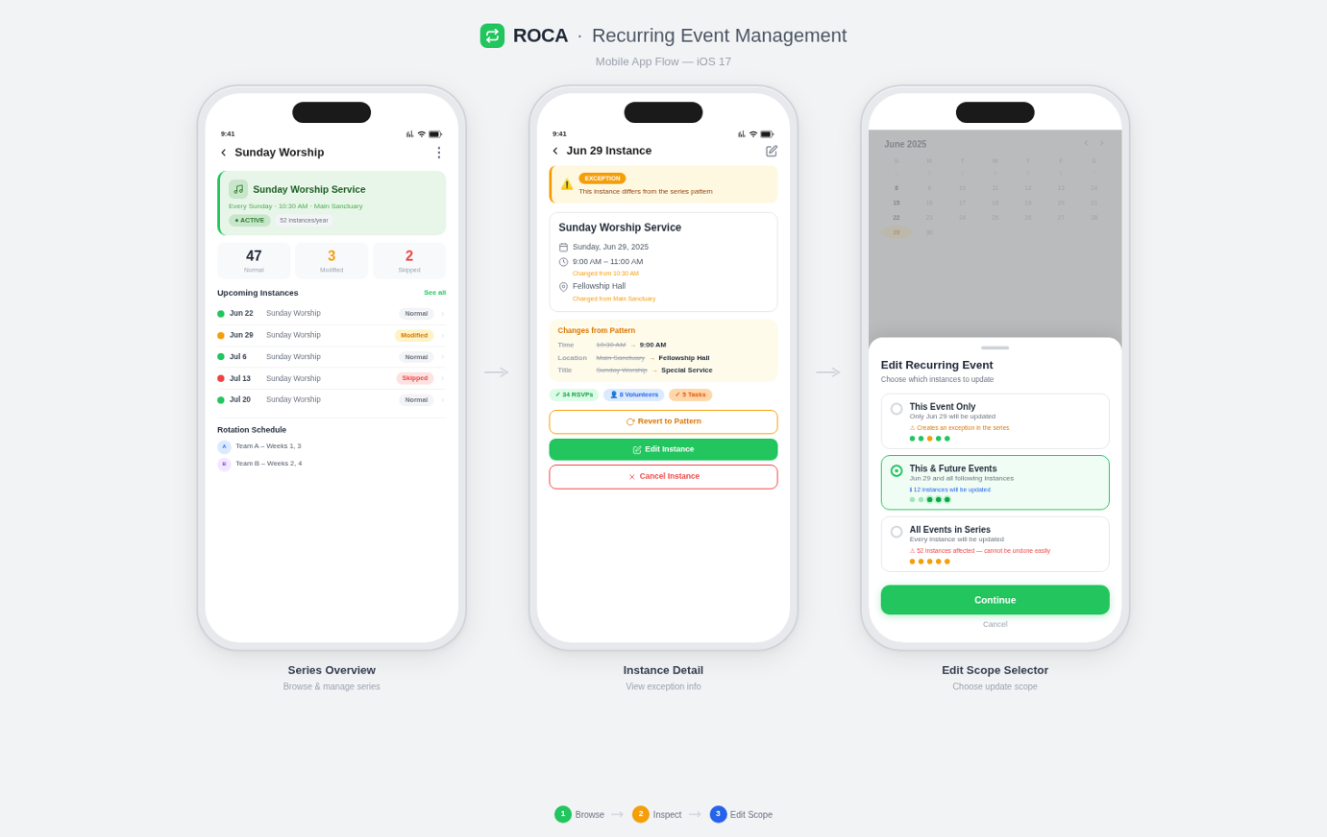
Figure 1 — ROCA Recurring Event Management: Batch 2 iPhone Screen Mockups (Series Overview | Instance Detail | Edit Scope Selector)

Screen 1: Series Overview
Recurring Series Summary — Stats · Instance List · Rotation Controls
2. Screen 1 — Series Overview
The Series Overview screen is the primary landing screen when a user selects a recurring event series from the calendar or event list. It presents an at-a-glance summary via stat chips, a scrollable chronological instance list, and a volunteer rotation strip for managing serving assignments.
2.1 Layout Zones
Zone | Region | Content / Components
Navigation Bar | Top 0–56 pt | Back arrow ←, Title “Weekly Worship — Series” (bold 17pt), ⋮ overflow menu (Edit / Delete Series)
Stats Card | 56–148 pt | 3 stat chips in a row: [12 Instances] [3 Exceptions] [Next: Sun Jun 8]. Chip bg #E8F5E9, text #1B5E20 bold 13pt
Rotation Banner | 148–196 pt | Horizontal scroll strip: volunteer rotation order avatars (3 visible + … more). Tap avatar → Profile sheet. Drag to reorder.
Instance List | 196–720 pt | Scrollable list rows. Each row: date pill (MMM DD), title, time, status badge (Scheduled / Exception / Cancelled). Swipe-left → [Edit] [Cancel] actions.
FAB | Bottom 82 pt | + Add Instance floating action button. Fixed above tab bar. Tap → New Instance modal.
Tab Bar | Bottom 0–82 pt | System tab bar: Overview (active), Calendar, Volunteers, Settings
2.2 Stats Chips Detail
Stat Chip | Data Source | Tap Action
12 Instances | series.instanceCount | Scrolls list to top
3 Exceptions | series.exceptionCount | Filters list to Exception rows only
Next: Sun Jun 8 | series.nextOccurrence ISO8601 | Scrolls to next upcoming row
2.3 Interactions & Gestures
Gesture / Action | Target Element | Result
Tap | Instance row | Push → Instance Detail screen (Screen 2)
Swipe-left | Instance row | Reveals [Edit] green & [Cancel] red action buttons
Long-press drag | Rotation avatar | Reorder rotation queue; haptic feedback on lift & drop; PATCH /rotation-order
Pull-to-refresh | List area | GET /api/v2/events/series/{id} to reload stats & instances
Tap FAB “+” | Floating button | Presents New Instance bottom sheet (half-modal, 50% height)
Tap overflow ⋮ | Nav bar | Action sheet: Edit Series | Delete Series | Export
2.4 API Endpoints — Screen 1
Method | Status | Endpoint | Purpose
GET | 200 | /api/v2/events/series/{seriesId} | Load series metadata, stats, and instance list
GET | 200 | /api/v2/events/instances?seriesId={id}&page={n} | Paginated instance list (20 per page, cursor-based)
PATCH | 200 | /api/v2/events/series/{id}/rotation-order | Update volunteer rotation sequence after drag-reorder
POST | 201 | /api/v2/events/instances | Create a new ad-hoc instance within the series
DELETE | 204 | /api/v2/events/instances/{instanceId} | Cancel / delete a specific instance
2.5 Edge Cases & States
- Empty state: “No instances yet. Tap + to add the first.” with illustration centred in list area.
- Loading state: skeleton shimmer placeholders in stat chips and list rows while GET /series fetches.
- Error state: toast banner “Could not load series. Pull to retry.” with retry affordance.
- Zero exceptions: exception chip hidden (not shown as 0) to reduce visual noise.
- Long series names (>32 chars) truncated with … in nav bar; full name visible in stat card subtitle.

Screen 2: Instance Detail with Exception Badge
Amber Banner · Change Summary · Contextual Actions
3. Screen 2 — Instance Detail with Exception Badge
The Instance Detail screen is displayed when a user taps any row in the Series Overview instance list. When the selected instance deviates from series defaults (i.e., an exception record exists), a persistent amber banner appears at the top of the screen to signal the deviation. Users can review change details, manage volunteers, and take contextual actions.
3.1 Exception Badge — Amber Banner Specification
! | EXCEPTION BADGE — Amber Banner  Displayed at the top of the Instance Detail screen whenever this instance deviates from the series default. Background #FFF8E1, left-border 4px solid #FFA000, icon ⚠️ 20pt. Message: “This instance has been modified. Changes apply to this occurrence only.”
3.2 Layout Zones
Zone | Region | Content / Components
Navigation Bar | Top 0–56 pt | ← back to Series Overview. Title = instance date “Sun, Jun 8”. Right: Share icon ↗
Exception Banner | 56–116 pt | ⚠️ amber strip: “This instance has been modified.” Tap → expands to show full change log inline. Dismissible via ×.
Hero Info Card | 116–260 pt | Event title (bold 20pt), Date-time chip, Location chip, Status badge pill (Exception — amber / Scheduled — green)
Change Summary | 260–400 pt | Diff list: each changed field shown as [Field] Original → Modified. Max 3 diffs visible; “Show all” expands.
Volunteers Card | 400–520 pt | Assigned volunteers avatar row + role labels. “Manage” link taps to Volunteer Assignment sheet.
Notes Card | 520–610 pt | Internal notes text area (max 500 chars). Edit icon top-right.
Action Bar | Bottom 130 pt | 3 buttons row: [Edit This] (green primary) | [Restore Defaults] (outlined) | [Cancel Instance] (red destructive)
3.3 Change Summary — Diff Fields
The Change Summary card renders a structured diff between the series default values and this instance's override values. Deleted fields are struck-through in red; added or modified fields show a right-arrow → separator.
Field | Original (Series Default) | Instance Override Value
Start Time | 09:00 AM | 10:30 AM — pushed 90 min
Location | Main Sanctuary | Room B — overflow venue
Lead Volunteer | James Okafor | Sarah Chen — substituted
Notes | (none) | Special setup required for audio. See notes.
3.4 Action Buttons
Button / Action | Style | Behaviour & API Call
Edit This Instance | Primary Green | Opens Edit Scope Selector bottom sheet (Screen 3). Scope pre-selected to “This Event Only”.
Restore Defaults | Outlined | Confirmation alert: “Restore all fields to series defaults?” → DELETE /api/v2/events/exceptions/{id}. Removes exception record; banner disappears.
Cancel Instance | Destructive Red | Confirmation sheet: reason selector + optional note → PATCH /api/v2/events/instances/{id}/cancel. Sends push notification to RSVPed attendees.
3.5 API Endpoints — Screen 2
Method | Status | Endpoint | Purpose
GET | 200 | /api/v2/events/instances/{instanceId} | Load full instance detail including exception fields
GET | 200 | /api/v2/events/exceptions/{instanceId} | Fetch exception diff data (changed fields)
DELETE | 204 | /api/v2/events/exceptions/{id} | Restore instance to series defaults (dismiss exception)
PATCH | 200 | /api/v2/events/instances/{id}/cancel | Cancel this instance; notify attendees via push
3.6 Exception Badge Rules
- Banner visible if and only if GET /exceptions/{instanceId} returns a non-empty diff payload.
- Banner auto-dismissed (animated fade-out) after Restore Defaults completes successfully.
- Tapping the banner expands an inline change-log accordion (max height 240pt, scrollable).
- Badge persists across navigation back to Series Overview as a small amber dot on the instance row.

Screen 3: Edit Scope Selector
Bottom Sheet · 3 Scope Options · Timeline Preview · Continue Action
4. Screen 3 — Edit Scope Selector (Bottom Sheet)
The Edit Scope Selector is a bottom sheet that appears whenever a user initiates an edit on an instance belonging to a recurring series. Its sole purpose is to clarify the blast radius of the edit: only this instance, this instance and all following, or every instance in the series. After selecting a scope, the user taps Continue to proceed to the standard Edit Event form.
4.1 Bottom Sheet Presentation
≡ | BOTTOM SHEET — Presentation Behaviour  Slides up from bottom edge. Detents: 55% (default) and 90% (expanded). Drag handle at top centre. Background dim 40% black scrim. Dismissible by swipe-down or tapping scrim. Not dismissible while a selection is in progress.
4.2 The Three Scope Options
Scope Option | Radio Label / Icon | Affected Instances & Description
This Event Only | ● Option A | Modifies only the selected instance. Creates or updates exception record. Other instances untouched. Default pre-selection when arriving from Instance Detail.
This and Following Events | ● Option B | Modifies selected instance and all future instances in the series. Splits the series at the selected date — a new sub-series is created from that point forward. Previous instances unchanged.
All Events in Series | ● Option C | Modifies every instance (past, present, and future). Updates the series template itself. All per-instance exceptions are overwritten. Shows additional confirmation step.
4.3 Timeline Preview
A horizontal timeline strip below the radio options provides an immediate visual preview of which instances will be affected. It updates in real time as the user changes scope selection, giving clear feedback before committing.
Timeline Zone | Visual Indicator | Behaviour when Scope Changes
Past instances | Grey dots ◦ | Always greyed-out; never affected by edit scope selection
Selected instance | Amber star ★ pulse | Always highlighted. Acts as the anchor point for “This and Following” split
Following instances | Green circles ● | Animate green when Option B or C selected; stay grey for Option A
Timeline label | Date strip | Shows short date (Apr 6, Apr 13, Apr 20…) for up to 5 upcoming instances inline
4.4 Layout Zones
Zone | Region (sheet %) | Content / Components
Drag Handle | Top 0–32 pt | Rounded pill handle 36×4 pt, color #CCCCCC, centred
Sheet Title | 32–88 pt | “Edit Recurring Event” bold 18pt centred. Subtitle: “Choose how far this change extends” 14pt grey
Scope Radio List | 88–280 pt | 3 tappable radio rows (Option A/B/C). Selected row bg #E8F5E9, border-left 3px #1B5E20. Animated on selection.
Timeline Preview | 280–400 pt | Horizontal dot-timeline. Reacts to scope selection with animated colour change (grey → green for affected dots).
Impact Counter | 400–452 pt | “3 events will be updated” counter chip. Updates instantly on scope change. Colour: green for A/B, amber for C.
Continue Button | 452–520 pt | [Continue →] full-width primary green button. Disabled until a scope is selected. Tap → navigates to Edit Form pre-populated with selected scope.
Cancel Link | 520–564 pt | “Cancel” text link centred, 15pt, grey. Dismisses bottom sheet without action.
4.5 API Endpoints — Screen 3
Method | Status | Endpoint | Purpose
PATCH | 200 | /api/v2/events/instances/{id}/exception | Option A: Update this instance only (upsert exception)
PATCH | 200 | /api/v2/events/series/{id}/split?from={instanceId} | Option B: Split series at this instance; update forward instances
PUT | 200 | /api/v2/events/series/{id} | Option C: Update entire series template; overwrite all exceptions
GET | 200 | /api/v2/events/series/{id}/impact?scope={A|B|C} | Fetch live impact count for timeline preview chip
4.6 Accessibility & Interactions
- Radio options: accessibilityLabel includes scope name and impact count (“This Event Only, 1 event”).
- Continue button: disabled state reads “Select a scope to continue” for VoiceOver users.
- Timeline dots: accessibilityHidden = true (decorative only); impact counter chip provides the same info.
- Swipe-down to dismiss must be confirmed if user has already selected a scope (prevents accidental loss).
- Keyboard / external input: arrow keys cycle through radio options; Return triggers Continue.

5. Design Tokens Reference
The following design tokens are shared across all three Batch 2 screens and should be referenced in the ROCA Mobile Design System (DS v2) Figma library.
Token | Value | Usage
color-primary | #1B5E20 | Nav bar, primary buttons, active state
color-exception | #FFA000 | Exception banner border & icon
color-warning-bg | #FFF8E1 | Exception banner background fill
color-destructive | #D32F2F | Cancel Instance button, delete actions
color-series-split | #F9A825 | Option B scope selector row highlight
radius-sheet | 16 pt top corners | Bottom sheet container border radius
font-body | SF Pro — 17pt / 20pt | Standard body text in all cards
animation-scope | 200ms ease-in-out | Timeline dot colour transitions on scope change

ROCA — Recurring Event Management — Batch 2 Mobile Screens — Mobile UI Specification
This document is intended for internal use. All screen dimensions are for iPhone 15 Pro (390 × 844 pt @3x). Designs subject to change through QA review.

